Overall dashboard
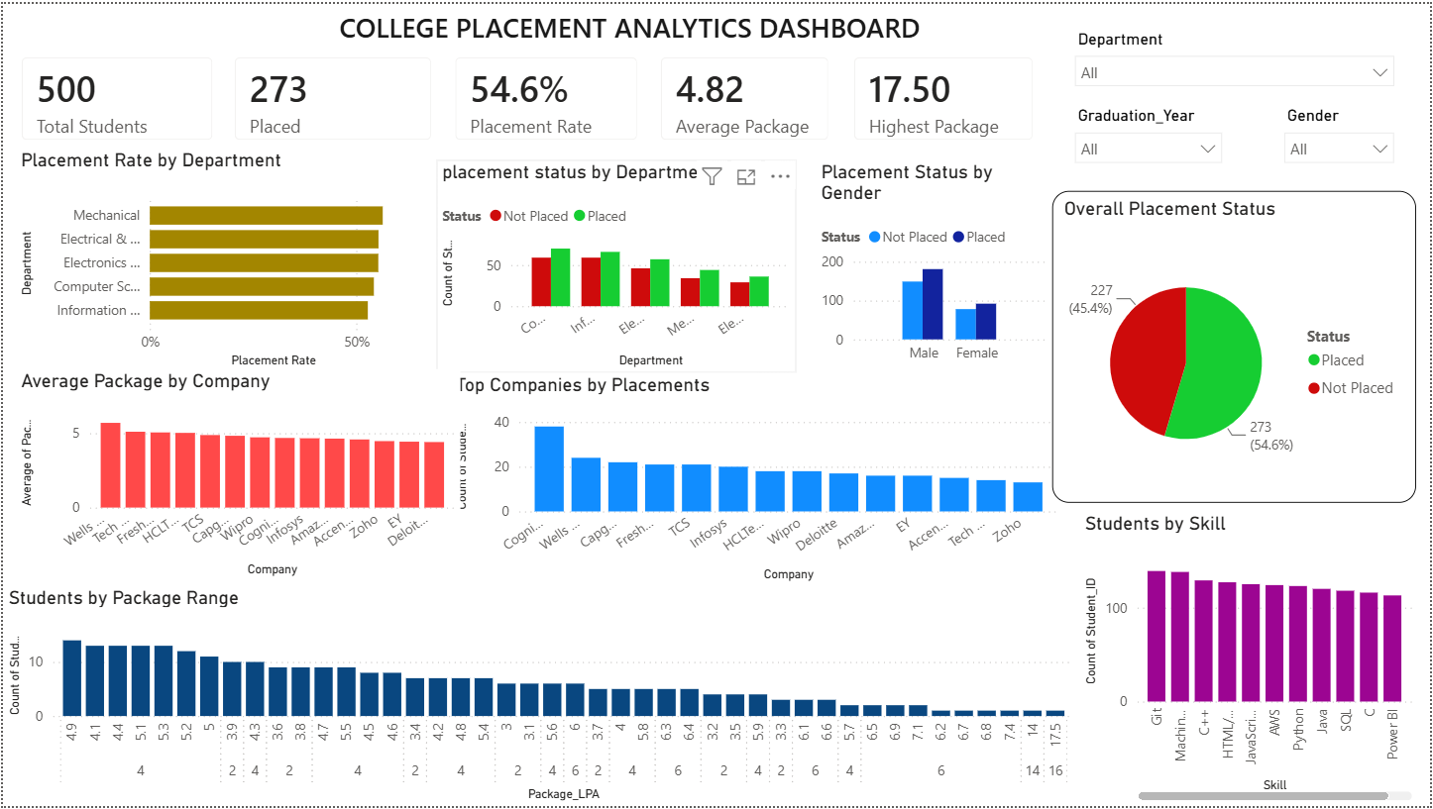

Placement records of students who are CSE Department
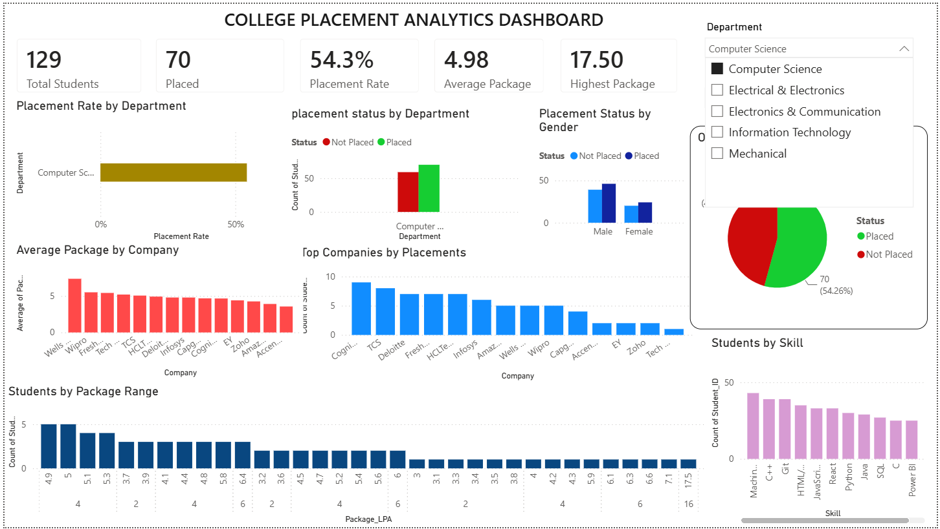

Data of placed students who’s gender is ‘Male’
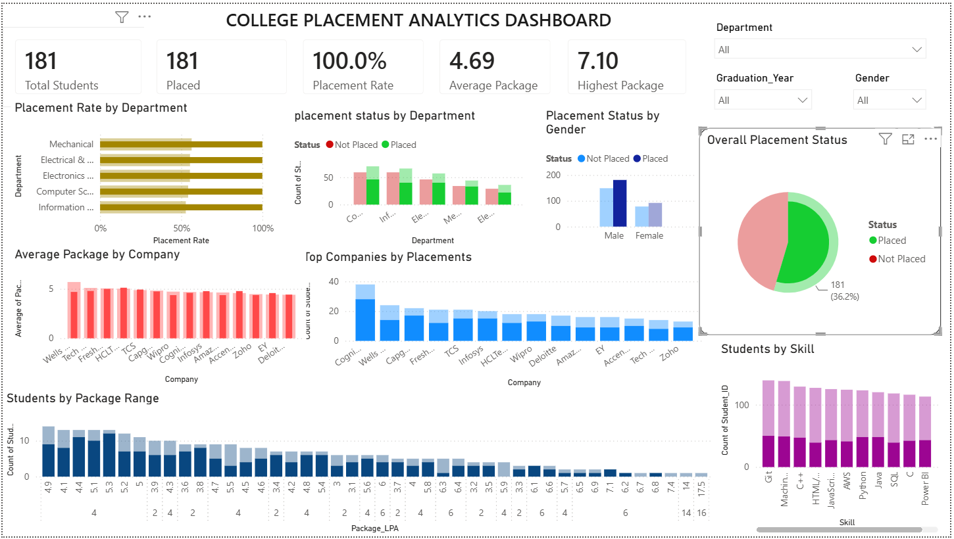

Data of placed students who’s package is ‘4.4 LPA’
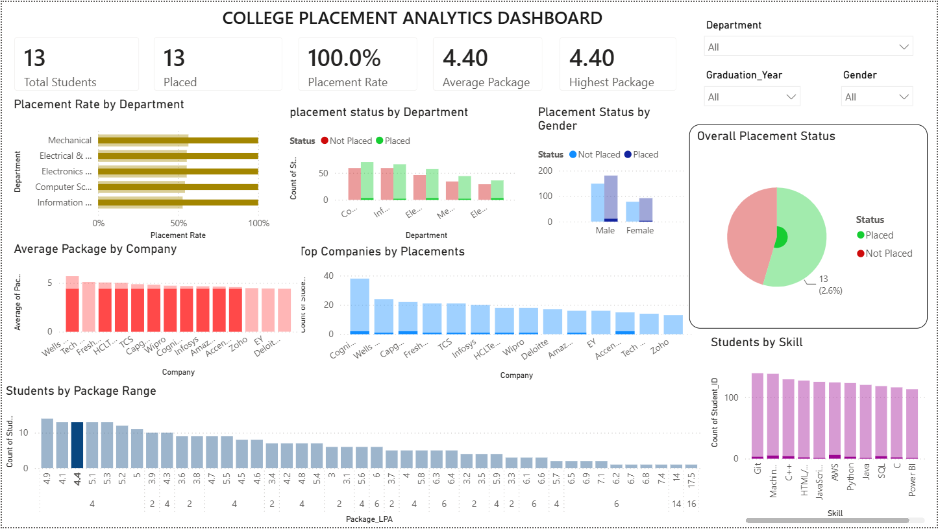

Data of students who are placed in ‘TCS’
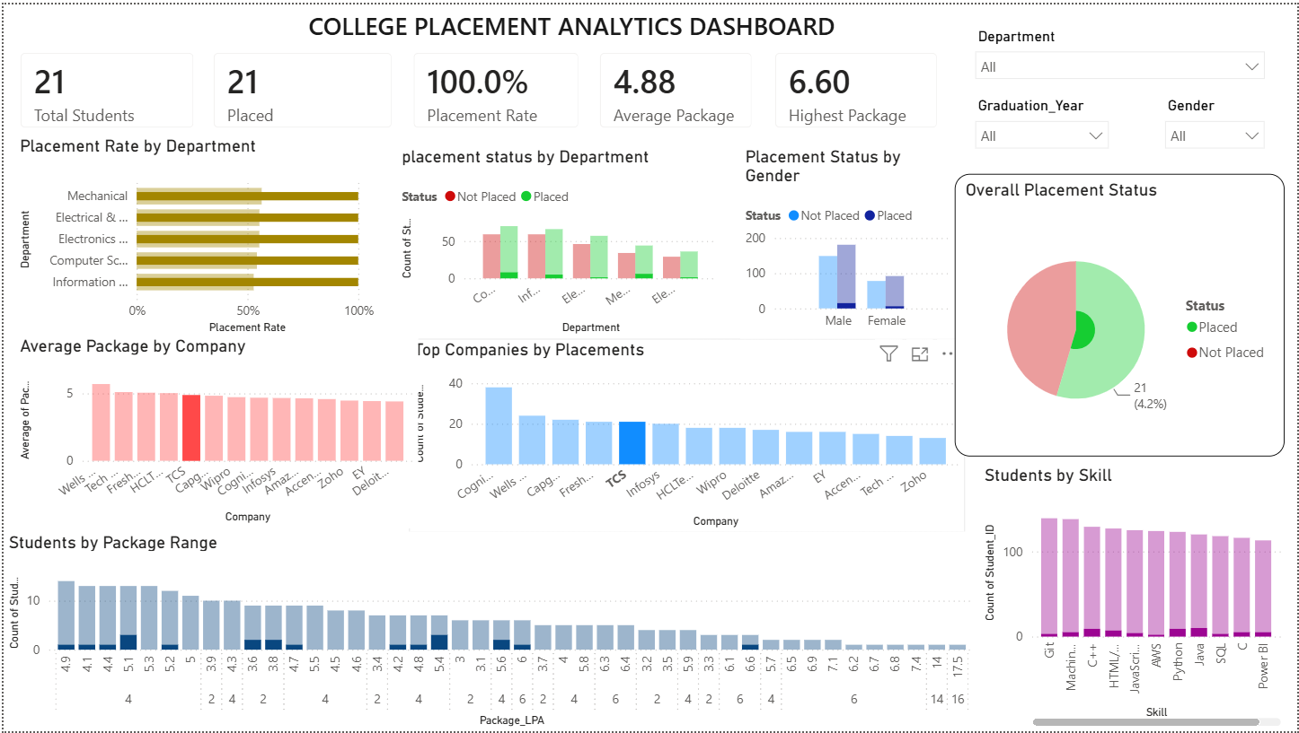

Data of students who are from Information Technology Dept, Graduation year is 2027 and the gender is Female
